Faculty Guide to the Major Work Plan

Choosing and declaring a major is a central task of the sophomore year and a significant component of the Sophomore Plan. The Sophomore Plan website has basic information; fuller information for students is available on the Sophomore Plan Moodle site.
As you prepare for your meetings with students in the sophomore class who hope to declare a major in your department or program, please keep in mind the following:

- Before drafting an on-line major work plan, students are advised to review the major requirements posted in the catalog and on the departmental websites, to talk with departmental faculty at office hours and departmental information sessions, and/or to make an appointment to talk with a prospective adviser. If you have strong feelings about what you want your prospective majors to do before meeting with you, please make them known at your major info sessions and online.
- Each time a student creates a tentative major plan in your field, their name may show up in your list of advisees. Unless the department has set it up otherwise, all continuing faculty members in your department will receive the tentative plan.
- Please do NOT approve any plans until you have spoken with the student and have confirmed the student’s intention to declare a major in your field. Doing so would freeze the student’s major plan and prevent the student from proposing another major instead!

Please follow the instructions below to review, revise, and approve the new on-line Major Work Plans. If you encounter technical difficulties with BiONiC, please contact Megan Kenny in the Registrar’s Office. If you have questions related to major advising, please contact Michelle Mancini in the Dean’s Office. If you have concerns about a particular student, please contact their dean.

Finding prospective majors in the new version of BiONiC
To access prospective majors long into BiONIC, then click on your ADVISOR CENTER and then select List of Student Majors from the left menu.

Students who have saved a Major Work Plan designating your department as their major will be included in this list, which will be available to all department faculty members to review via the Advisor Center.

Finding the student you are looking for
A list of all your prospective and existing majors will open. It will include the student’s name, ID number, and graduation year and whether or not they have been approved. You can search by any of these fields. To view each student’s tentative major plan, click on the View Major Work Plan

If you don’t see the student’s name listed, it may mean that they have not filled out the form correctly and specifically have not entered any courses into the “planned” section. Please let them know they need to do that. If they say they have and they are still not visible to you, please direct them to the Registrar’s Office.

Reviewing the prospective major’s Major Work Plan:

(If you are an experienced major adviser, nothing in this part of the process has changed.)
A Major Work Plan includes Courses Completed and In Progress, Planned Courses and Additional Notes. Below is a brief overview of each section.

Courses Completed and In Progress

This section includes all courses a student has enrolled in or completed that have been coded as counting towards the major. The student is asked to check off courses to be included and to leave out those with grades below merit or those that are extraneous. For example, a student who has completed three 100-level Anthropology courses will only count two towards the major. Check to be sure they have correctly identified courses for the major and that they have received at least a 2.0.
Occasionally, a student will have completed a course—perhaps an allied course, or one at another school-- that doesn’t pop up on this list. Students have been instructed to list them under Planned Courses or Additional Notes with a note that shows that they are cleared.

Here’s an example of a prospective biology major’s list of Courses Completed and In Progress:

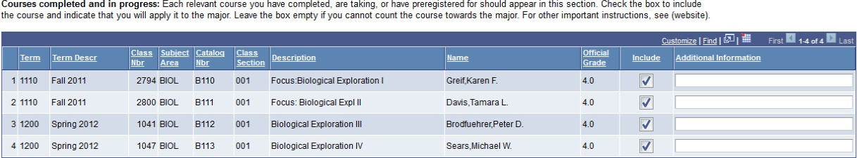

Planned Courses
Students are advised to consult departmental webpages and talk with faculty before filling this section out. The computer will allow them to choose from those Bryn Mawr and Haverford courses that have been offered over the years (not all of which will ever be offered again), to indicate which semester they hope to take each course, and to write notes about each one as needed. During your meeting with your prospective advisee, you and the student may edit this section, choosing different courses or different semesters and revising the notes.

If a student intends to use a course from outside the Bi-Co towards the major, the student may include the Bi-Co equivalent in this list along with a note such as “I hope to replace this with a course at LSE”. Or, the student may leave the course off this list and mention it instead in Additional Notes.

Here’s an example of a prospective physics major’s somewhat haphazard list of planned courses:

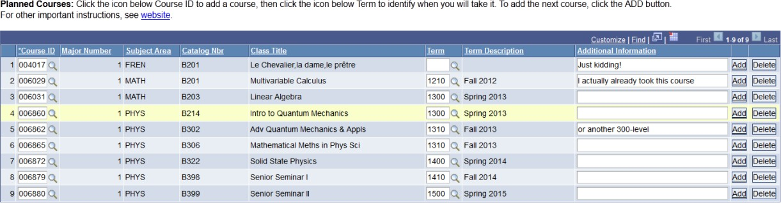

The Planned Courses section is where essential advising happens. The expectation of an approved online Major Work Plan is that the Completed and Planned Courses sections together should constitute a COMPLETE major in the major field. Moreover, ideally, it would not include excess courses. This way the student can come back to the major work plan for a schematic of what they have done and still need to do in the department to complete the major and graduate.

Additional Notes
Under additional notes, students may elaborate on their plans or request guidance from major adviser. Notes might include plans for Study Abroad, a plan to take a Penn course towards the major, or a request for clarification as in the example below.

Because you will add notes here in the future, it’s important that the student and you sign and date your notes.
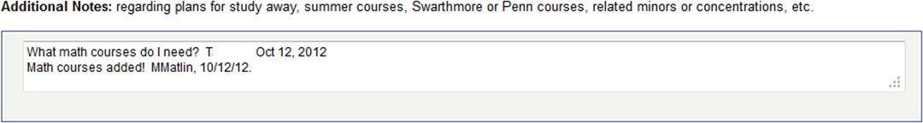

Double Majors
If a student is proposing a double major at the time of declaration, this will be indicated on your Advisor Center list of majors. Here’s an example of two students who are proposing majors in both anthropology and biology. Note that the major adviser in biology has already approved these plans:
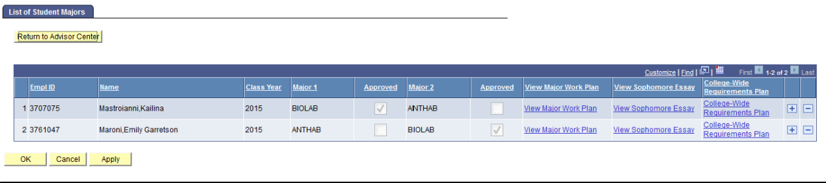

Before approving students for a double major, please review both major plans and discuss their plans with them in person. If you remain concerned about a proposed double major, please contact the student’s dean.

Factor in Study Abroad plans
Students indicate if they plan to study abroad in their Major Work Plan as follows:

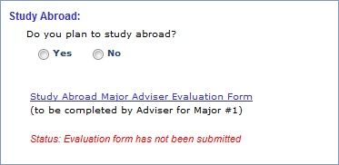Student indicates their intention to study abroad.
Major adviser completes an evaluation form for students applying to study abroad. The form itself and the information provided on the form will not be accessible to students.
Message indicating whether or not the evaluation form has been submitted.
Please be sure to discuss students’ study abroad planning as it relates to their major planning.

Students applying to go abroad during their junior year will need a Study Abroad Major Adviser Evaluation Form (completed by their adviser for Major #1) as part of their study abroad application. This form is located in the Study Abroad section of the Major Work Plan. Before you complete this form, the student should discuss the student’s study abroad plans in detail with you, including the semester the student plans to go abroad and the programs the student is considering. Please reach out to students who have not met with you prior to completing this form. Once a form has been submitted a message stating “Status: Evaluation form has been submitted” will appear that will be visible to both you and the student (see screen shot above). The form itself and the information provided on the form will not be accessible to students. You can read about this process in the context of study abroad more generally on the For Faculty section of the Study Abroad website.

Approving and saving a Major Work Plan
Once you are satisfied that the student’s plan constitutes a complete and feasible path to complete the major, you must officially approve the students’ Major Work Plan by checking the red box that says “Major Work Plan Approved,” then pressing the yellow “Save” button. It is only when both those steps have happened that the student is officially declared. It can take 24 hours or so to update in
BiONiC and for the student’s approval to be reflected in your Advising Center.
Your approving the major will “freeze” the Major Work Plan for the student, who will not be allowed to change majors on line or to make any changes, updates or revisions to the plan. However, YOU as the major adviser will still be able to make changes throughout the student’s undergraduate career. Any updates you make will be visible to the student and the student’s dean. Your department can also make arrangements with the Registrar to allow all faculty in your department access to the plan, including the ability to update it.
Many faculy advisors will instead opt to just record updates in the notes session of the online major work plan; this also works.

