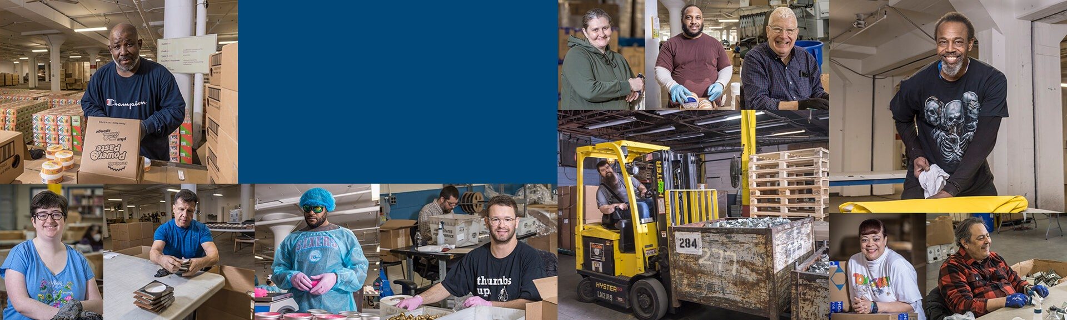
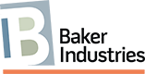
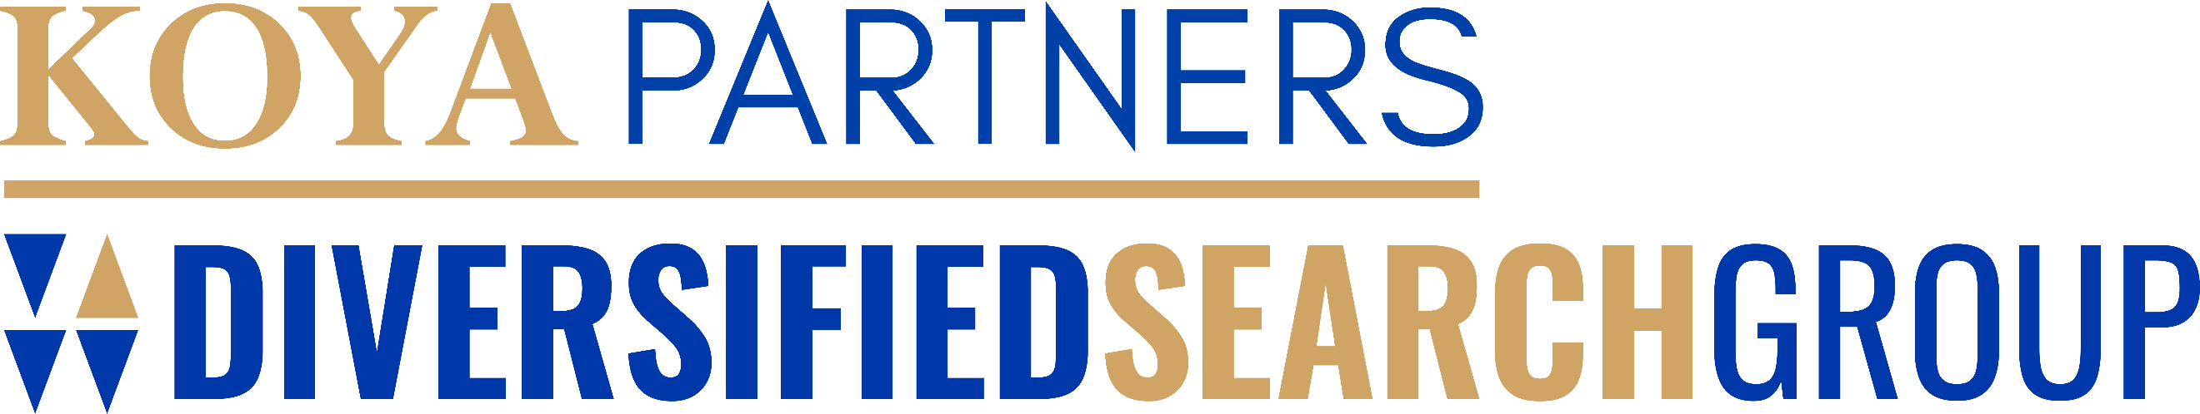

Baker Industries President
Malvern/Philadelphia, PA

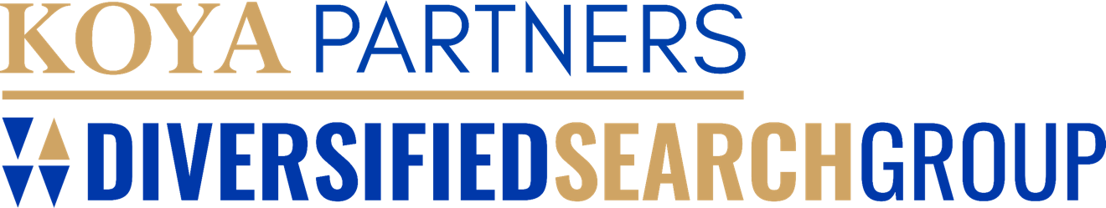

About Baker Industries
Baker Industries (Baker) is one of the Philadelphia region’s most highly regarded workforce development programs serving and employing adults with barriers to employment since 1980. Each year, Baker provides paid work assignments and job readiness training in a trauma-informed setting for up to 200 individuals challenged by parole/probation, substance use disorder, disability, and homelessness. We bring talented, traditionally undervalued people off the sidelines into the workforce, working in a collaborative team environment to build skills and capabilities that prepare them for success with local companies. Dozens of individuals make the leap from Baker Industries to regular employment annually.

Unique among workforce development programs, Baker program
participants perform real work for real customers for a real wage. We serve a wide range of local companies with packaging and mailing services, competing every day with for-profit entities. We believe there is no substitute for real work experience to prepare individuals for regular employment. We perform our work in two large, well- maintained warehouse operations, one in north Philadelphia (Kensington) and one in the western Philly suburbs (Malvern).

Individuals earn a paycheck from Baker Industries, along with innovative job readiness training and coaching that helps them reach their potential as effective and productive employees. Dozens progress to regular employment each year. Baker Industries strengthens communities across Philadelphia. We believe that a good job is foundational to addressing systemic poverty, recidivism, recovery and financial stability. Baker Industries says “yes” to job seekers who often only hear “no.” In doing so, Baker Industries changes lives.

Learn more about Baker Industries at https://www.bakerindustries.org/.

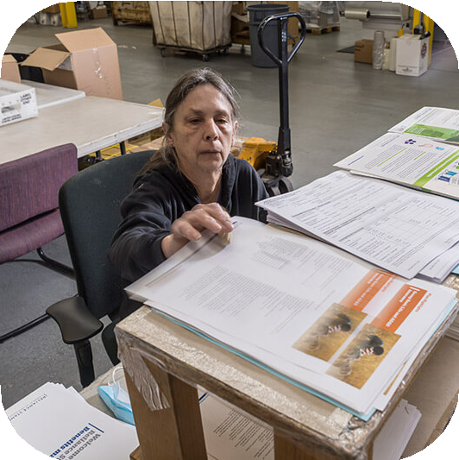
The Opportunity
Baker Industries is looking for a President who can build upon a strong foundation of tradition, while also bringing an innovative and entrepreneurial mindset as Baker Industries looks to the future. The President will be responsible for overseeing and leading on strategic initiatives, trauma-informed programming, operational efficiency, dynamic fundraising, and excellent customer relations. Additionally, the President will continue to foster collaborative community partnerships that forward Baker’s mission and increase impact.

With an annual budget ranging from $2.2M - $2.4M, eight full- time staff, four part-time staff, and up to 70 program participants, the President will be inheriting a strong balance sheet and team of people to help realize its mission. The President will bring a
creative approach to revenue generation building upon a strong donor base of grants, individual giving, and business revenue from our packing services.

Reporting into the Board of Directors consisting of 21 diverse and talented professionals from across the Philadelphia business and community service sphere, the President will be a collaborative and communicative leader.

Leading with empathy and compassion, the President will be a hands-on leader, not only for the team but also the employees working within the program. Open to new ways to scale and impact, the President will bring a growth- mindset ensuring that Baker Industries thrives in a dynamic landscape. The role is a unique opportunity to not only lead an organization focused on lasting impact but also support and serve a community that has been underserved.

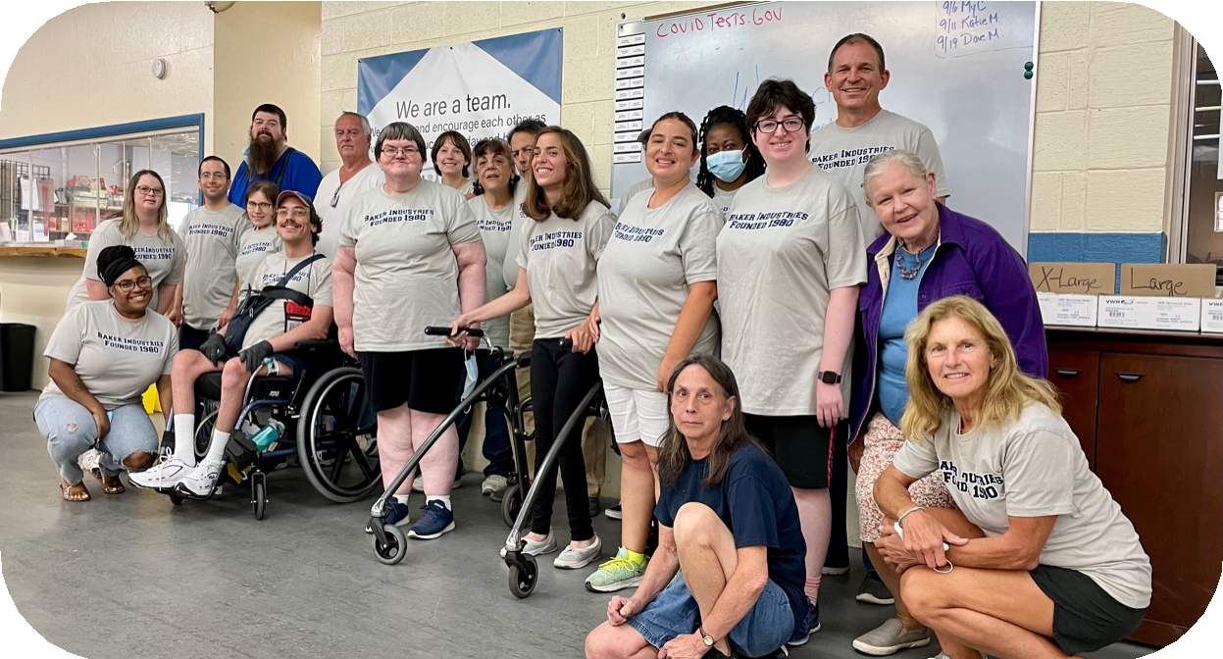

Candidate Profile
We recognize that there is a spectrum of lived and professional experience that will set candidates up for success in this role. While no one candidate will have every experience outlined in the position description, ideal candidates will display the following professional and personal qualities, skills, and characteristics:

Passion for Mission
The President will be a dedicated individual with a deep connection to Baker Industries’ mission of helping vulnerable adults successfully reenter the workplace and earn a wage. Through the lens of trauma-informed work, the President will provide program leadership to ensure effective training and development for all program participants. Additionally, the President will be the driving force behind the collective success of the organization and foster a culture of empathy where individuals can show up as their best selves.

Strategic Leadership
This individual will be a strategic and visionary leader experienced in steering organizational change, able to conceptualize a compelling vision, craft strategic approaches, and execute effectively. The President will work in partnership with staff, Board, and community to create a clear pathway for Baker Industries to continue to fulfill its mission while also thinking about the different ways to grow and scale impact for the people and communities it serves. Additionally, the President will lead a diverse team of professionals and front-line workers.

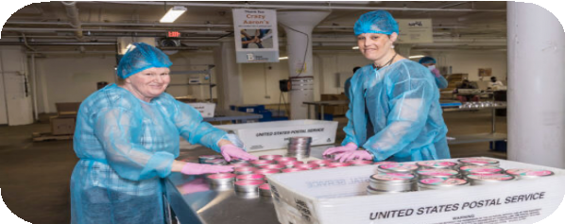
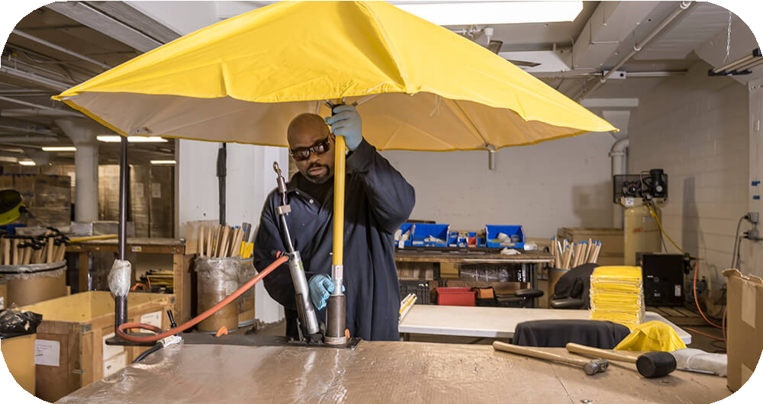

Operations and Business Acumen
Operating with a keen understanding of organizational dynamics, the candidate will also provide operational leadership, ensuring the safety, effectiveness, and efficiency of Baker Industries' core processes. The selected individual will be inherently accountable for the overall success of the enterprise, making executive decisions, and ensuring financial fidelity. Including finance, operations, and administrative tasks, the President will be leading both a business enterprise responsible for service delivery and an understanding of nonprofit best practices.

Brand Ambassador and Relationship Builder
As the external-facing brand ambassador for Baker Industries, the President will be responsible for developing and maintaining effective relationships with a diverse group of constituents including program participants, staff, Board Members, community partners, donors and customers. With a dynamic and engaging style, the President will be able to convey Baker’s mission and goals to garner support for the organization. Additionally, the President will be responsible for revenue generation, both identifying new revenue sources, as well as building on current supporters. With an ability to build and nurture effective partnerships, the President will be a genuine, empathic,
and compassionate leader.

In addition, strong candidates will:
- Foster a culture rooted in respect and trusted by all.
- Ensure the integrity of Baker Industries in all practices.
- Provide transparent and regular reporting to the Board of Directors, auditors, regulators and other organizations as required.
- Represent Baker Industries in the community, seeking value-based collaborations with other organizations in the for-profit, non-profit and government sectors that align with our mission.
- Bring fundraising experience through grants, campaigns and events that build sustainable support for the mission.

Compensation & Benefits
Salary for the role is anticipated to range from $110,000 - $130,000 commensurate with experience with a bonus opportunity. Baker Industries offers benefits - vacation, health and retirement. Baker is open to hearing from candidates who might be outside of this range to remain competitive with the market.

Contact
Koya Partners l Diversified Search Group has been exclusively retained for this engagement, which is being led by Alicia Salerno and Tatyana James. Submit a compelling cover letter and resume by filling out our Talent Profile. All inquiries are strictly confidential.

Baker Industries is an equal opportunity employer and strongly encourages applications from people of color, persons with disabilities, women, and LGBTQ+ applicants.

About Koya Partners l Diversified Search Group
Koya Partners, a Diversified Search Group company, is the nation’s premier search firm dedicated to mission- driven leadership. Since its founding in 2004, Koya has had an exclusive focus on mission-driven clients and was founded on the belief that the right leader can transform an organization and have a deep and measurable impact on our world. Koya works with nonprofits & NGOs, responsible businesses, and social enterprises in local communities and around the world.

Diversified Search Group is consistently recognized by Forbes on its top 10 list of “America’s Best Executive Recruiting Firms” and is an industry leader in recruiting transformational leaders for a changing world. The firm is deliberately different in its approach, with best-in-class teams who have decades of experience in cultivating inclusive leaders, understanding the dimensions of diversity, and building equitable teams.

Learn more about Koya Partners l Diversified Search Group via the firm’s website.

