To View Plan Information and Enroll:
- Go to: www.uhcsr.com/brynmawr
- Once on the site, look for Medical – Pre-Med Post-Baccalaureate Student Plan and select Explore Policy.
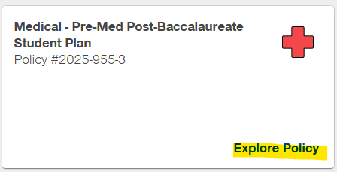
- Select Summary Flyer to view Plan Details.
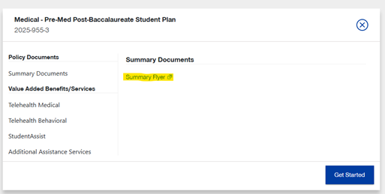

- To start the enrollment process, select get started.
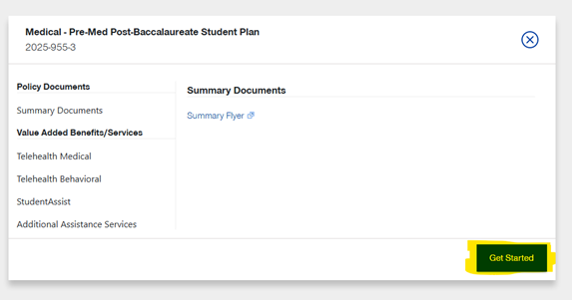

- Select Continue as guest to enroll and establish your account.
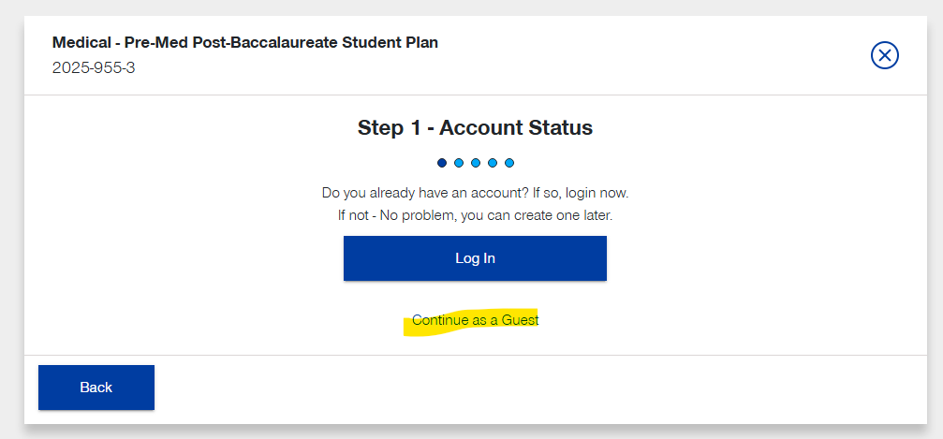
- You will be redirected to the enrollment site. Select Opt-In.
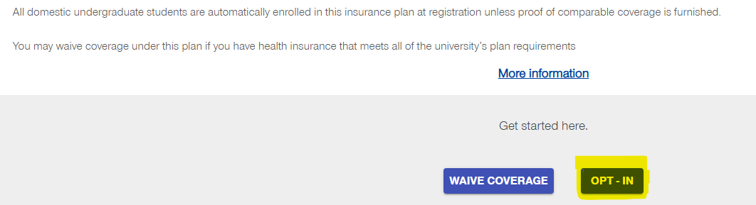
- Enter your date of birth and student ID without any leading 0s. If you enter the 00s, you will receive an error message.
