

Instructional Booklet

Learning Agreement and
Process Recordings

LEARNING AGREEMENT

HOW TO USE THE LEARNING AGREEMENT:

Instructions and Sample Learning Agreement

The Learning Agreement will be used to inform the Final Evaluation for all students in field placement. The Student, Field Instructor, and Field Liaison will use the learning goals & assignments described in the Learning Agreement, along with the practice competencies and measurable behaviors listed on each page of the evaluation to guide learning as defined by the Council of Social Work Education (CSWE) Educational Policy and Accreditation Standards (EPAS).

The Learning Agreement is a working document that can be updated and revisited throughout the field placement. Identified goals and assignments are designed to promote the professional growth and development of the student through practical and hands-on tasks, projects, and applications of the social worker role. The student and Field Instructor will collaboratively complete the Learning Agreement to determine the goals and expected professional development of the student. Goals will focus on the particular needs of the student as well as the mission of the social work profession. These goals will aid in integrating classroom learning with experiences in a real-world fieldwork setting, to maximize and make clear the student’s growth.

Students and Field Instructors are encouraged to add their own unique learning goals, experiences and activities to meet student and agency professional objectives, and to work in concert to create educationally sound learning experiences that help students meet learning outcomes.

The Final Evaluation addresses the core competencies required for Field Education. The Learning Agreement provides a guide for the evaluation of the student’s performance and represents competencies to be achieved by the end of the placement. The Final Evaluation is the primary method of documenting that students have acquired these competencies. Field education learning goals and assignments are directly related to the competencies and behaviors.

LEARNING AGREEMENT

The Learning Agreement provides a broad framework for developing an individualized learning plan which is responsive to the needs of the student and the resources of the field agency. It is designed to give direction and learning structure to the field experience and is developed around the core practice competencies that are designated in the 2015 Educational Policy and Accreditation Standards (EPAS) by the Council on Social Work Education (CSWE). It is the joint responsibility of the Student and Field Instructor to negotiate the learning agreement content within the first weeks of the field placement. The Student is responsible for providing a copy of the Learning Agreement to the Field Liaison.

The Learning Agreement establishes learning objectives for the students that are feasible and attainable and serves as a tool to identify what the student will learn and what activities will be a part of the placement experience. The process of formulating a learning agreement also provides an early opportunity for students to take an active role in shaping their own learning and for students and field instructors to develop a good working relationship with each other. The agreement is considered to be a working document and should serve as a guide for supervision throughout the year.

Learning Goals and Assignments

There are two components to the learning agreement:

- Learning goals/objectives: (What new knowledge, skills and values do students want to learn?); --and--
- Learning strategies, or assignments: (How will students reach their learning goals?)

The Student and Field Instructor should determine learning goals in partnership as they complete the Learning Agreement Students are to identify learning goals they wish to achieve in their field placement. Students and Field Instructors may refer to the list of the EPAS 9 core competencies and their respective behaviors (pp. 4-5), in developing the Learning Agreement. Students will be evaluated and provided with feedback on all behaviors. Field Instructors are expected to ensure that supervisory sessions have a clear plan and focus, adhere to agreements made, and provide student with critical feedback related to their performance and assignments. In developing learning goals, consideration should be given to the following:

- Field agency services and programs
- Field agency history, philosophy, policies and procedures
- Needs of the client population
- CSWE EPAS competencies and behaviors
- Student’s expressed goals, motivations and interests
- Student experience level and learning style
- Classroom assignments, listed in course syllabus (provided to the field instructor by the student)

Developing the Learning Agreement

Planning for the development of the learning agreement should begin during the first two weeks of the field placement. By the third week, a draft of the learning agreement should be developed, with the final version ready for viewing by the Field Liaison in the fourth week of the semester.

The following steps can be followed in developing the learning agreement:

- The Learning Agreement may be completed in draft form in consultation with the Field Instructor, and saved in Sonia by the Student. The Field Instructor can review the draft, suggest any changes in the "Field Instructor Comment" section, and save the form, with their comments as a draft. The student then reviews, incorporates the Field Instructor's comments, and "submits". The Field Instructor then reviews the student's final submission, removing any suggested comments as needed, and "submits" for Field Liaison review.

- The Learning Agreement is due for final submission/Field Liaison review by the end of the 4th week, no later than September 24, 2021 for the fall semester.

- The Field Liaison may recommend additional changes to the Learning Agreement; these changes can be incorporated into the Learning Agreement by the student in consultation with the Field Instructor. Following these changes, the student can resubmit their revised Learning Agreement for final Field Liaison review/approval.

- The Learning Agreement may be amended/revised at the end of the fall semester, or at the beginning of the spring semester, or at another point during the school year as needed, in consultation with the Field Instructor. Revisions are made as some objectives are met and new ones are added and as the student's activities and learning needs change. If revised in the spring semester the Learning Agreement must be resubmitted for Field Liaison review no later than January 21, 2022. If no change is made, the original Learning Agreement remains in effect in the spring semester.

Learning Agreement and EPAS

The Learning Agreement is designed to give direction and learning structure to the field experience and is developed around the 9 core practice competencies that are designated in the 2015 Educational Policy and Accreditation Standards (EPAS) by the Council on Social Work Education (CSWE). CSWE has operationalized these competencies by identifying behaviors defined as “a set of measurable behaviors that are comprised of knowledge, value and skills.” The field placement plays a key role in teaching behaviors to students while measuring and reflecting the student’s ability to demonstrate capacity in the ten core competency areas identified by CSWE. The goal is for students to achieve proficiency in each competency listed below, to become competent in the corresponding Behaviors, and to find ways to integrate classroom knowledge with practice experience.

A sample Learning Agreement is included to assist students and field instructors in developing appropriate goals and assignments. Please consult your Field Liaison if you have additional questions.

Learning Agreement

The final version of the learning agreement is signed by the student and field instructor, and is retained by the faculty liaison. Copies should be kept by the student and field instructor.

- List at least 5 learning goals you hope to accomplish in your field placement site over the course of the year.

- List Assignments or Tasks that you will complete to help you attain your learning goal

- Indicate the CSWE Educational Policy and Accreditation Standards (EPAS) core competency to which the goal relates.

NOTE: All 9 EPAS competencies must be reflected among the goals. Goals may reflect multiple competencies.

Foundation Learning Agreement Sample

Goals | Assignments/Tasks | EPAS Competencies
Understand how grief may affect development across the life cycle and learn to provide supportive intervention to individuals and families in clinical and community/home setting | - Student will be assigned 4 clients to begin and will carry out home visits and psychosocial assessments with each.  - Student assignment will include a diverse client population to facilitate a deeper understanding of how grief impacts individuals at different stages of life and with differing cultural identification(s).  - Student will provide process recordings of work with at least two clients.  - Student will present cases in case conference and  adhere to agency’s compliance standards. | - Competency 1  - Competency 2  - Competency 3  - Competency 4  - Competency 5  - Competency 6  - Competency 7  - Competency 8  - Competency 9
Learn about group dynamics and group leadership skills with bereaved spouses/partners | - Student will help facilitate and develop activities for a therapeutic support group for bereaved spouses/partners meeting every other week. | - Competency 1  - Competency 2  - Competency 3  - Competency 4  - Competency 5  - Competency 6  - Competency 7  - Competency 8  - Competency 9
Learn to identify and take steps address signs of burnout in the course of providing support for bereaved individuals, families, and groups | - Student will identify ways to cope with stress related to working with extreme loss and discuss implementation with supervisor. | - Competency 1  - Competency 2  - Competency 3  - Competency 4  - Competency 5  - Competency 6  - Competency 7  - Competency 8  - Competency 9
Learn about the resources available for individuals and families coping with loss, and the impact of agency structure and healthcare policy on individuals and families | - Student will read agency policy and procedure manual  - Student will meet other staff in the agency and gain a better understanding of their roles and function  - Student will become familiar with a range of resources for individuals and families, and the funding sources and application process for each | - Competency 1  - Competency 2  - Competency 3  - Competency 4  - Competency 5  - Competency 6  - Competency 7  - Competency 8  - Competency 9
Learn about evidence-based interventions in work with bereaved populations and their use in the agency setting. | - Student will review (2) articles on intervention with grief and loss and discuss with supervisor  - Student will evaluate the outcome of an intervention with a client/family/group by looking at change in the presenting problem over time. | - Competency 1  - Competency 2  - Competency 3  - Competency 4  - Competency 5  - Competency 6  - Competency 7  - Competency 8  - Competency 9

Advanced Clinical Learning Agreement Sample

Goals | Assignments/Tasks | EPAS Competencies
Learn about evidence-based interventions in work with adolescents and their use in the school setting | - Observe individual meetings between supervisor and students  - Review student files to familiarize self with student’s experience and current needs, including IEP goals  - Manage case load of ?/approximately ? students, with whom I will meet for one session per week  - Develop intervention strategies to increase academic success, strengthen social interaction skills, and help students in understanding and accepting themselves and others  - Practice setting SMART goals with students  - Evaluate the outcome of an intervention with a student by looking at change in the presenting problem over time | - Competency 1  - Competency 2  - Competency 3  - Competency 4  - Competency 5  - Competency 6  - Competency 7  - Competency 8  - Competency 9
Fall Edits to Goals: Manage case load of four students (by end of fall  semester) | Fall Edits to Assignments/Tasks: meet with four students for one session per  week
Spring Edits to Goals: Manage case load of six students (by end of spring  semester) | Spring Edits to Assignments/Tasks: meet with six students for one session per  week
Understand how depression and anxiety may affect development of adolescents and learn to provide supportive intervention to students in a school setting | - Review (2) articles on intervention with depression and anxiety and discuss with supervisor  - Provide classroom support as needed  - Evaluate the outcome of an intervention with a student by looking at change in the presenting problem over time | - Competency 1  - Competency 2  - Competency 3  - Competency 4  - Competency 5  - Competency 6  - Competency 7  - Competency 8  - Competency 9
Spring Edits to Goals: Continue to increase level of responsibility and independence in accordance with expectations for a final semester clinical  student | Spring Edits to Assignments/Tasks
Develop and improve skills with facilitating student groups | - Facilitate group sessions for five students meeting once weekly  - Provide process recording of work during at least one group session  - Present notable events from group in supervision | - Competency 1  - Competency 2  - Competency 3  - Competency 4  - Competency 5  - Competency 6  - Competency 7  - Competency 8  - Competency 9
Understand development and revision of Individualized Education Programs (IEPs) | - Observe IEP meetings  - Assist with creating an IEP | - Competency 1  - Competency 2  - Competency 3  - Competency 4  - Competency 5  - Competency 6  - Competency 7  - Competency 8  - Competency 9
Learn about resources available for adolescents and families coping with self-defeating behaviors and the impact of school district structure and policy on students and their families | - Attend family support group meetings  - Work with families as needed to facilitate support for students’ school adjustment  - Become familiar with a range of resources for students and families at the school and the funding sources and application process for each | - Competency 1  - Competency 2  - Competency 3  - Competency 4  - Competency 5  - Competency 6  - Competency 7  - Competency 8  - Competency 9

Advanced Macro Learning Agreement Sample

Goals | Assignments/Tasks | EPAS Competencies
Demonstrate ability in managing and supervising a group while maintaining the goal of increasing awareness regarding social inequalities | - Provide assistance and guidance to new hotline volunteers during the orientation period  - Develop comprehensive knowledge of training materials for hotline volunteers  - Develop competence in administrative duties in the establishment of special task force  - Work with supervisor in the area of recruiting,  interviewing, and hiring new hotline counselors. | - Competency 1  - Competency 2  - Competency 3  - Competency 4  - Competency 5  - Competency 6  - Competency 7  - Competency 8  - Competency 9
Fall Edits to Goals | Fall Edits to Assignments/Tasks
Spring Edits to Goals | Spring Edits to Assignments/Tasks
Increase communication skills toward effective provision of feedback | - Carry out the role of hotline counselor and refine listening skills with callers  - Provide feedback to hotline volunteers during training and supervision  - Work with coordinator to assist with recording of participant interaction in special task force meeting | - Competency 1  - Competency 2  - Competency 3  - Competency 4  - Competency 5  - Competency 6  - Competency 7  - Competency 8  - Competency 9
Increase knowledge of services to hotline caller, including referral to appropriate resources and advocacy | - Complete hotline counselor training  - Learn about multiple resources for providing social and legal information  - Observe court session to learn about potential caller experience, and inform response to callers’ concerns | - Competency 1  - Competency 2  - Competency 3  - Competency 4  - Competency 5  - Competency 6  - Competency 7  - Competency 8  - Competency 9
Improve knowledge of development, including grant- writing and fundraising | - Assist supervisor with grant-writing and donor appeals | - Competency 1  - Competency 2  - Competency 3  - Competency 4  - Competency 5  - Competency 6  - Competency 7  - Competency 8  - Competency 9
Improve understanding of relationships with organizational stakeholders, including members of the board, volunteers, staff, and clients | - Attend board meetings  - Assist in the development and implementation of a cultural competency training for new volunteers | - Competency 1  - Competency 2  - Competency 3  - Competency 4  - Competency 5  - Competency 6  - Competency 7  - Competency 8  - Competency 9

PROCESS RECORDINGS

It is expected that student Process Recordings will be used in field supervision, with either written or verbal feedback provided by the Field Instructor. Process recordings are an effective way of learning interviewing skills and reflecting on one’s practice. All students in field placement are required to become familiar with recording the process of interaction with clients and client systems. The Process Recording can be used in both direct practice/clinical settings with individuals, families, or small groups, as well as Macro Practice settings in work with larger client systems such as task groups, organizations, or communities.

Depending on students’ field setting and assignments, successive process recordings may focus on on- going work with one client/client system. Also depending on the field setting, in the first semester there may be a period of time necessary for students to acclimate themselves to the agency and begin work with clients, before completing a full Process Recording.

Students are expected to complete 3 process recordings per semester on the dates indicated for each assignment. All Process Recordings must be signed by the Field Instructor in order to be considered complete. Field Instructor comments may be included in submitted Process Recordings, but are not required. While the exact submission date of student Process Recordings may vary based on the timing and types of assignments provided, it is expected that these assignments will be completed and submitted according to the due dates listed below. If a student anticipates a delay in timely submission of an assignment, they are expected to notify their Field Liaison in advance of the due date to make arrangements for an alternate submission date. Dates for submission of Process Recordings fall and spring semesters are provided below. Incomplete or delay in process recording submissions may impact the final grade for the course.

Fall Semester:

Process recording #1 Due October 1, 2021
Process recording #2 Due October 29, 2021
Process recording #3 Due December 3, 2021

Spring Semester:
Process recording # 4 Due January 21, 2022
Process recording #5 Due February 25, 2022
Process recording #6 Due March 25, 2022

INFORMATION THAT SHOULD GO INTO PROCESS RECORDING

There are various formats for completing a process recording. The following outline covers the major areas to include within a process recording of session with an individual or family, co- facilitation/facilitation of any type of a group, or work on a Macro project/assignment at the organizational or community level. In the case of a group, the process recording should include information regarding dialogue and non-verbal behaviors engaged in by specific members of the group. Group dialogue should show group interaction, to the extent possible, to show an understanding of process, and/or to review with field instructor the group dynamics. In the case of the Macro project/assignment and/or work with a task group, the content should include group dynamics, tactics and strategies, dialogue to illustrate group process, and thoughts feelings and analytical thoughts about what was happening. It should also include discussion of challenges or obstacles/issues that hinder the accomplishment of the group's task.

Students may use either the “column” format template (as shown in the “sample” that follows), or a narrative format (description of the interview/contact content and student’s observation/thoughts/ feelings in paragraph form) for completing a process recording. All content areas below must be included when using either format. Field Instructor comments can be added to any of the sections of the recording.

Identifying information
For work with individuals or families: Include student’s name, date of interview/contact. Identify the client/family/group (disguise or remove client name to protect confidentiality in submission to Field Liaison.) Include the number of times this client/family has been seen and/or the group has met (i.e., "Fourth contact with M. S. /S. family/ group"). If client/family is seen or group meets in location other than the agency, state the general location where client was seen

For group: Include date of group meeting, identify the approximate number of group members and the number of times it has met, as well as the location of the meeting Objectives of interview, meeting, activity, event, project, etc.:

For Macro: Include the date and discuss the objectives of the interview, meeting, activity, event, project; Describe/explain the project/assignment and its purpose; identify the need that the assignment/project will be meeting for the agency/community, and the goal of the project. Describe the chronology of events.

- “Tuning In.” This is the preparation phase of an interview/contact with client/family/group. Anticipate the client’s/family or group members’ thoughts, feelings, issues, as they enter the interview/group session. Also consider your own thoughts and feelings as you anticipate this interview/group session.

- Purpose and goal for the interview/contact. Brief statement of the purpose of the interaction and if there are any specific goals to be achieved, the nature of the presenting issues and/or referral.

For Macro: In this section the student refers to aims, goals, and objectives, and describes what needs to be accomplished in the meeting or interaction. The student identifies specific steps, actions, decisions and timelines that need to be established to make a change.

Column or Narrative format:
- Content. A description of what happened, as close to actual dialogue as the student can recall, should be completed. This section does not have to include a full interview/group session of dialogue but should include a portion of the interview/session. The field instructor and student can discuss what portion(s) should be included in the content section.

- Reflection and feelings. The student's feelings and reactions to the client/group members and to the interview/group process. What are they feeling at the moment (anxious, confused, etc.)? What are they noticing in themselves? This requires the student to put into writing unspoken thoughts and reactions they had during the interview/group session, e.g. "I was feeling angry at what the client was saying, not sure why I was reacting this way…”

- Observation/Analysis. Thoughts about what has happened during the interview/group (e.g., Why is he acting this way?) and/or identification of skills, interventions or theoretical/frameworks used (e.g. “I used the strengths perspective“; “I used the skill of partializing”; "When I was feeling (....), now that I look back, I used (........) strategy").

For group process recording, student observation/analysis can speak to:
  - Dynamics of the group (i.e., rather than only on the content of what is said). For example, if this is the first process recording for a particular group, consider the following questions. What group rules emerge? What leader behaviors are displayed? How are decisions made? How active is the facilitator(s)?
  - Climate/group atmosphere: For example, how are feelings (as opposed to points of view) dealt with? Were issues dealt with and how were they dealt with? How is difference and diversity dealt with in the group? What non-verbal behavior indicates changes in the climate? What are the roles of various group members and how do they influence the climate of the group?
  - Group leadership/facilitation: What group dynamics are observed; what group building behaviors (bringing in silent members, harmonizing conflict, reinforcing participation, etc.) is student/co- facilitator engaged in?
  - Communication patterns creating barriers or obstacles to the group process.

For Macro: Include questions, uncertainties; evaluation of practice and observations about how tasks might have been done differently. Include use of the following skills:
  - Analytical skills (ability to evaluate social problems and develop policy options and proposals)
  - Political skills (ability to negotiate, compromise, confront, and collaborate to influence both threats and opportunities)
  - Interactional Skills (ability to take a leadership role in task groups, committees, and coalitions, and to persuade other people to support specific agenda)
  - Value-Clarifying Skills (ability to identify the values underlying activities/policies, such as social justice, equality, equity, societal and collective rights, and freedoms [privacy, confidentiality, autonomy, and self-determination]

Field Instructor’s Comments.

- A summary of the student's impressions. This is a summary of the student's analytical thinking about the entire interview/contact and/or any specific interaction about which the student is unsure. What did you learn from this interview? Are there any patterns in your practice emerging more distinctly?

- Future plans/Next steps. Identify any unfinished business and/or any short/long term goals. Given all of the above, what are you planning to do next time with the client? Are there things that need to be researched, learned, or considered, prior to the next interview? Is your overall purpose still appropriate? For Macro: (What possible next steps are recommended? What changes or plans might be required? How might this project or similar projects be adjusted going forward?)

- Identify questions for supervision. Include any client action or non-verbal activity that the student may want to discuss.

- Reflection on supervisory discussion with Field Instructor. Following supervision, discuss what you have learned about your practice, and the competencies and/or behaviors relevant to your learning.

PROCESS RECORDING FOR GROUP SESSIONS

A process recording can also be used when a student is co-facilitating/facilitating any type of group. The process recording should include information regarding dialogue and non-verbal behaviors engaged in by specific members of the group. Group dialogue should show group interaction, to the extent possible, to show an understanding of process, and/or to review with field instructor on group dynamics.

The Group Process Recording should also begin with the sections, as noted for the individual client process recording:

- Identifying information. Include date of group meeting, and date of submission to the field instructor. Identify the approximate number of group members and the number of times it has met, as well as the location of the meeting.

- “Tuning In.” This is the student’s preparation phase for a group meeting. Anticipate the group issues, as the group begins. Also consider your own thoughts and feelings as you anticipate this group session.

- Purpose and goal for the group, overall, as well as for this session.

Either the column or the narrative format can also be used for process recordings of groups. The
“Observation/Analysis” portion can include student commentary on:

- Dynamics of the group (i.e., rather than only on the content of what is said). For example, if this is the first process recording for a particular group, consider the following questions. What group rules emerge? What leader behaviors are displayed? How are decisions made? How active is the facilitator(s)?

- Climate/group atmosphere: For example, how are feelings (as opposed to points of view) dealt with? Were issues dealt with and how were they dealt with? How is difference and diversity dealt with in the group? What non-verbal behavior indicates changes in the climate? Discuss the roles of various group members and how they influenced the climate of the group.

- Facilitation: What group dynamics are observed; what group building behaviors (bringing in silent members, harmonizing conflict, reinforcing participation, etc.) is student engaged in?

- Communication patterns creating barriers or obstacles to the group process.

Process Recording Sample – Columns Format

Content Dialogue | Reflection & Feelings | Observation/Analysis | Field Instructor Comments
A description of what happened, as close to actual dialogue as the student can recall, should be completed. This section does not have to include a full interview/group session of dialogue but should include a portion of the interview/session.  Record word for word (to the best of your ability) what happened during the selected segment of the interview, including both verbal and nonverbal communication. Be certain to include third-person participants, interruptions, and other occurrences that were not part of the planned session/interview  with the client. | The student’s feelings and reactions to the client/group members and to the interview/group process as it takes place. What are they feeling at the moment (anxious, confused, etc.)? What are they noticing in themselves? This requires putting into writing unspoken thoughts and reactions as the interview/group session is going on. E.g. “I was feeling angry at what the client was saying, not sure why I was reacting this way…” | This column can be used to analyze one’s own interviewing techniques and to suggest alternate approaches that might have been more effective; or, one’s observations and thoughts regarding what has been happening during the interview. E.g., in the course of carrying out the interview, the student is thinking: “I wonder what he really meant by that statement? That seems to contradict what he told me earlier.” | In this column, the supervisor can make remarks right opposite the interaction, feeling level, or observations that have been recorded.
The field instructor and student can discuss what portion(s) should be included in the content section. | Do not use this column to analyze the client’s reactions – use it to identify and look at your feelings. | This column can also be used to add thoughts about what has happened during the interview/group (e.g., Why is he acting this way?) and/or identification of skills, interventions or theoretical frameworks used (e.g. “I used the strengths perspective”; “I used the skill of partializing”; “When I was feeling (…), now that I look  back, I used (…) strategy”).

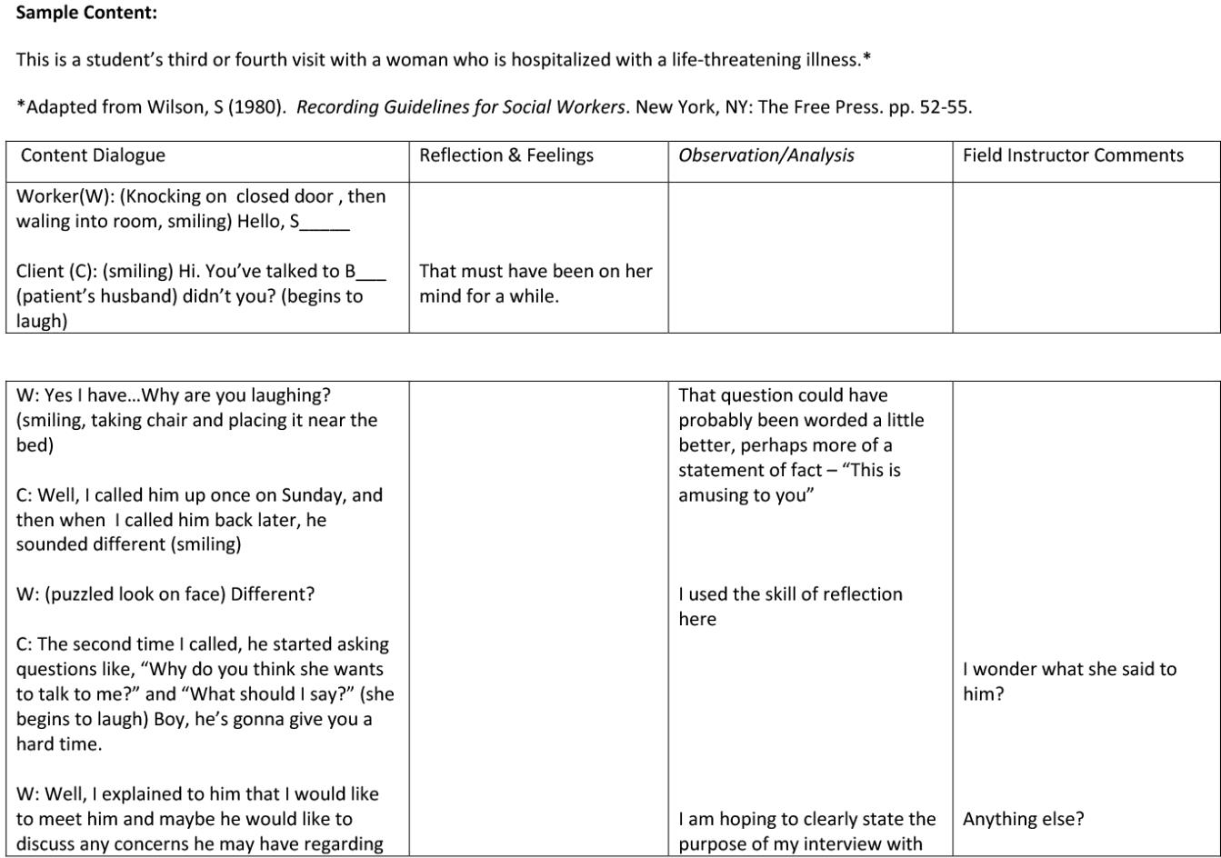

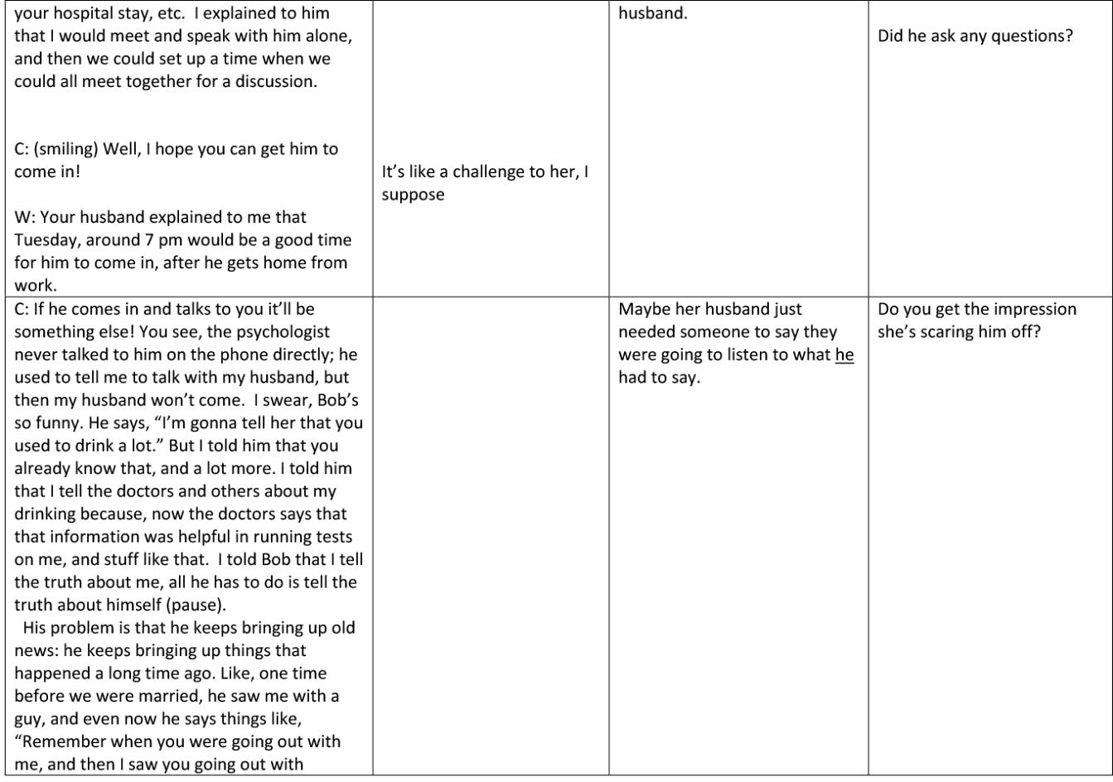

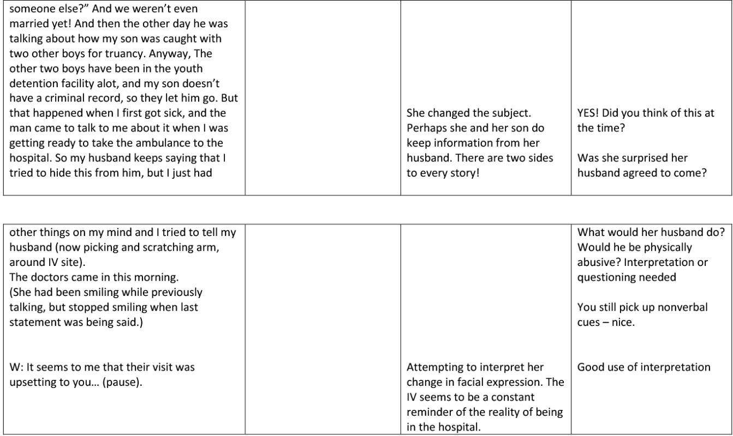

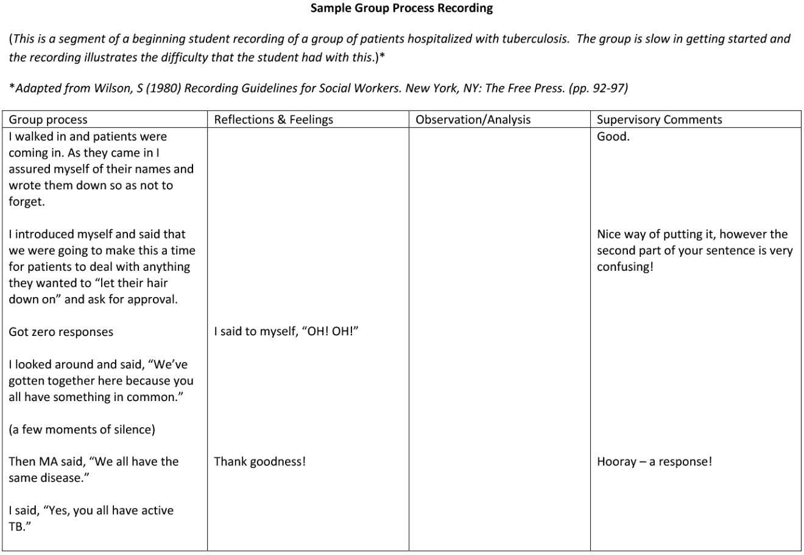

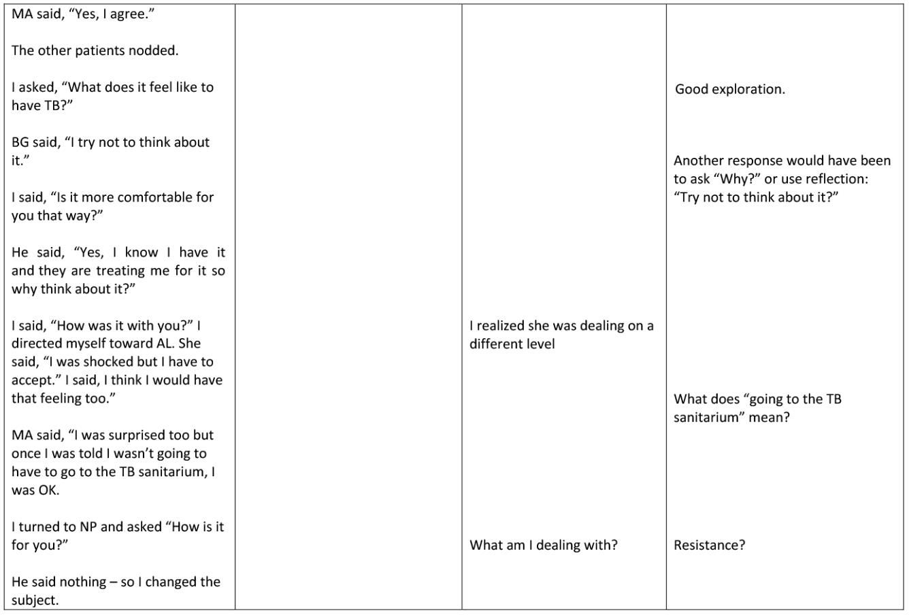

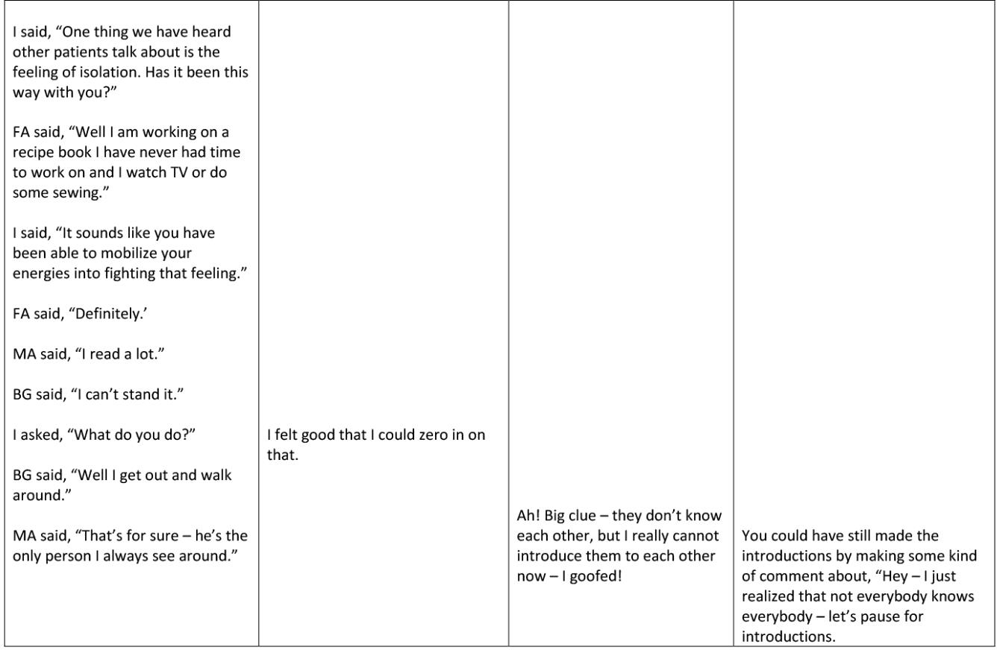

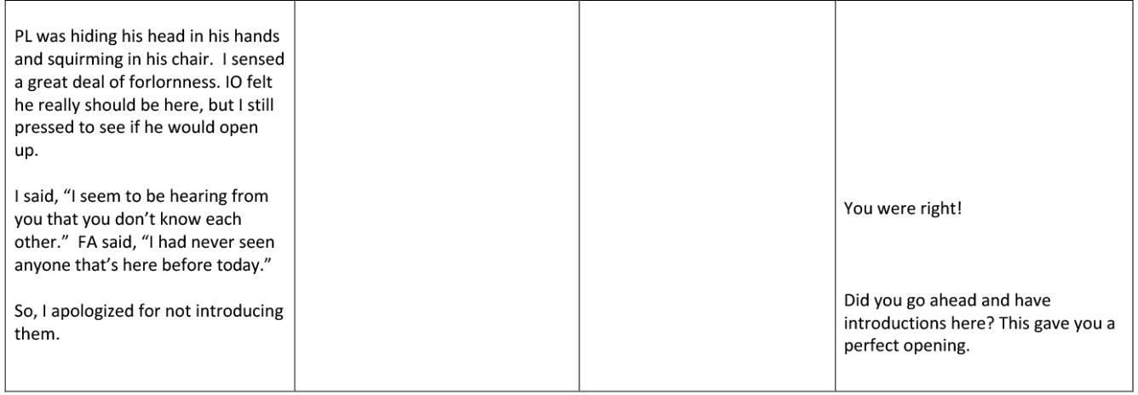

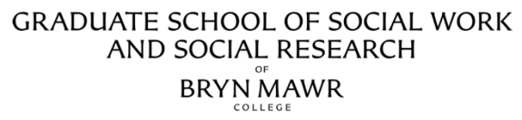

Macro Practice: Communities, Organizations, Policy, & Advocacy Process Recordings

Process Recording can be used to reflect on work with larger client systems and/or on a longer-term a Macro assignment, and to show steps that are being taken to complete the assignment. It is an educational tool for both the student and Field Instructor to use with specific learning goals in mind. The purpose is for the student to be able to recall the contact, report detail, comment on his/her activities, review the work done, and plan for future activity. Field instructors’ comments can be included near the related discussion, or at the end of the recording, and can highlight intervention and assessment skills, as well as the skills for monitoring and critiquing one’s work.

The following excerpt focuses on the interactions of four coalition key stakeholders and the student:*

*Adapted from, Medina, CK (2010), The Need and Use of Process Recording in Policy Practice: A Learning and Assessment Tool for Macro Practice, Journal of Teaching in Social Work, 30: pp. 29-45)

Student’s description of history/background/context of coalition: The coalition is an ad hoc alliance of individuals from the medical, faith, academic, and public safety communities. It is interdisciplinary and incorporates different perspectives. During the summer, the Chairperson (from the faith-based community) reached out to the medical community to address youth violence in the inner city from a public health perspective. The summer brought with it a significant rise in youth gun violence. The community responded to this violence by demanding action from the faith-based community.

Student’s description of the meeting goals and objectives:
- To organize speakers when meeting with the government official;
- To break down the meeting into components that tie into the coalition’s mission statement when
addressing the official; and
- To work closely with the consultant in response to the RFP

Student’s description of meeting being processed: In the meeting, much discussion ensued about identifying the problems associated with youth violence in the inner cities. The members had consulted with community stakeholders and investigated the relevant power structures. They are ready for action after problem identification and needs assessment. They are preparing to meet with an elected official to explain their concerns, and the need for a public health approach to youth gun violence.

Content Dialogue | Reflections and Feelings | Observation/Analysis | Supervisory Comments
Rob: We are meeting with a public official. Our message to him must be succinct and powerful.  Gus: We must tie in our concern to youth violence and the pervasiveness of the problem. [Silence.]  Rob: Let’s discuss an outline for this one hour meeting. I think first there will be a review of the statistical data.  Lance: I suggest that Gus be responsible for presenting the info.  Gus: It should be targeted and not too wordy.  Rob: That’s why I assigned you this task.  Gus: There must be a discussion of a public health approach.  Barbara: Can I interject? I want to talk about an RFP to help inner cities develop alternatives to youth violence. There is a consultant needed to develop an action plan on youth violence.  Someone from this committee needs to take | There was much excitement, tension, and anxiety from all members. Partially, it was because of the meeting with the elected official and having our voices heard. The other "feelings" were about the RFP and our need  to influence through our power as a coalition.  Some members were threatened by an outsider as a consultant. The Chair, Lance, seemed worried that the members were verbose and would not deliver to the public official the coalition’s concerns and solutions in a meaningful way.  The data presentation felt too long, and I was afraid we would lose focus. Many of the group members began to talk over each other. Usually Lance grows uncomfortable with the committees’ majority voice of medical members. Today, he let the medical providers continue to take the lead, defining violence as a public health issue. At times, he used humor, which deflected  some tension, like when | At the moment, when Gus presents many details about the research and data, he is interrupted by Barbara. Barbara is more concerned with their status, legitimacy, and power as experts in youth violence. She objects to an outsider coming in on our movement. | You are experiencing the coalition struggling with its development. How did the coalition decide on the public health perspective on youth violence?  Explain the decision- making process.  What factors influenced the group? You have made some good observations, but tell me more about what makes Lance vital to the process? Tell me some of the strategies the coalition is using? Explain the power/influence dynamics operating, and why the group seemed threatened by outsiders as consultants? Does the group know your role, and who you represent? Why do you feel that they were annoyed? Let’s discuss the process, your intimidation, and leadership further in supervision.

this on. I don’t want an outsider acting as our expert consultant when the coalition has been so active in this movement.  [Student is nonverbal and observing. There is much talking over one another, putting pressure to respond to RFP. I responded after about 15 minutes and after several glances from Gus.]  Student: The Y agency director may be interested in consultation, and I can check if she is willing to take on the RFP.  Gus: That’s a great idea, and I can help if there is anything I can do. I am willing to meet with your director.  Rob: Then let’s discuss  an outline for this one hour meeting with the mayor. | he stated he assigned Gus the task of presenting the material. Everyone laughed because we all know he is wordy.  I felt the group was annoyed that I did not come forward earlier with the RFP. I felt intimidated and somewhat ineffectual. I felt powerless, but Gus’ glances encouraged me to speak up. He knows my work and that of the agency.

Student reflection/summary: The group has a way of discussing several items at one time and losing its focus. Lance is a man of few words and wants action. The interactions among the different disciplines, their perspectives, and discussions are interesting to observe. My feelings of intimidation silenced me, although I was observing. I was very much a quiet participant. I know Lance is vital to the group because of his focus and need to keep us on track. He accomplished his agenda setting and the points to be discussed with the mayor after a rough beginning. I was able to assist with the RFP and legitimized the agency as a resource on youth violence. Gus did glance at me, and this pressured me to take an active role by discussing the agency’s potential interest in the RFP. This intimidation, however, limited my role in the meeting. My young age in relationship to the others also contributes to my lesser status. If I never speak up, I’ll have trouble developing my skills, especially interactional and leadership skills. In the future, I need to explain my position with more confidence.

PROCESS RECORDING OUTLINE
Narrative Model

- IDENTIFYING INFORMATION: Include student’s name, date of interview/contact, and date of submission to the field instructor. Identify the client (disguise or remove client name to protect confidentiality in submission to Field Liaison.) Include the number of times this client has been seen (i.e., "Fourth contact with S."). If client is seen in location other than the agency, state the general location where client was seen.

- TUNING IN (This is the preparation phase of an interview/contact with client. Anticipate the client’s thoughts, feelings, issues, as they enter the interview. Also consider your own thoughts and feelings as you anticipate this interview.)

- FOCUS FOR WORK/PURPOSE AND GOAL FOR THE INTERVIEW/CONTACT: Brief statement of the purpose of the interaction and if there are any specific goals to be achieved, the nature of the presenting issues and/or referral.

- CONTENT OF INTERVIEW: A description of what happened, with sections of actual dialogue as well as client and student actions/responses, and relevant background/contextual description. Should include:

REFLECTION AND FEELINGS: The student's feelings and reactions to the client and to the interview. This requires the student to put into writing unspoken thoughts and reactions they had during the interview e.g. "I was feeling angry at what the client was saying, not sure why I was reacting this way…”

OBSERVATION/ANALYSIS: Thoughts about what has happened during the interview (e.g., Why is he acting this way?) and/or identification of skills or theoretical/frameworks used.( e.g. “I used the strengths perspective “ ; “I used the skill of partializing.”)

- SUMMARY OF STUDENT'S IMPRESSIONS:This is a summary of the student's analytical thinking about the entire interview/contact and/or any specific interaction about which the student is unsure. What did you learn from this interview? Are there any patterns in your practice emerging more distinctly?

- FUTURE PLANS/NEXT STEPS: Identify any unfinished business and/or any short/long term goals. Given all of the above, what are you planning to do next time with the client? Are there things that need to be researched, learned, or considered, prior to the next interview? Is your overall purpose still appropriate?

- IDENTIFY QUESTIONS FOR SUPERVISION: Include any client action or non-verbal activity that the student may want to discuss.

Sample Process Recording Narrative Model *

Interview with Client

Tune-in

Carl is beginning to feel more comfortable with me. I am hoping that he will soon disclose information to me concerning his father and mother and his home. I think he is beginning to trust me, so I believe it will make the sessions better. I know that every time that he comes to see me he is mad because he wants to go home. I feel bad for him because he wants to go, but also know that he cannot return yet. It would be very discouraging to him if he had to come back. I feel very stuck with the case, but I am ready and willing to try to work and intervene not only with Carl, but with his mother and father as well. I am trying to alter his perception about the people at work and his feeling that no one is doing anything for him. I feel it is easy to talk with him about subjects that he wants, but he does not want to talk about what needs to be discussed. I feel I really need to talk about his relationship with his father and mother but I feel that he wants to avoid it.

Focus for Work/Connection to Overall Purpose

For today's session, I would like to explore his feelings that no one understands. I want him to see that I know that I cannot completely understand what he is doing, but that I am willing to listen and try to comprehend it. I think this may show him that I do care and am interested in how he is feeling. I feel it is a relatively safe topic and that it could be a good way to establish more trust in our working relationship. This relates to our long-term goal because it will give me a better understanding of how he views Green Manor. It will also tell me how he is feeling, besides angry, about placement and what I do not understand. It is important to explore this. He could share with me how he feels like he is getting lost in the crowd and why. I am hoping that he may be able to tell me a definite example of how he is forgotten and to try to remedy it.

Content

Today's session was rather interesting and did not go as well as I thought it would. I feel very overwhelmed and confused almost at the happenings. First, I called for Carl to be sent down to my office. He came a few minutes later and was excited to see that I had the art supplies. We talked a little about that and then he told me he had a good weekend. He said he played football and was happy because his mother had brought his cleats up on Thursday. He asked me a "really huge" favor, which was to have his sister come to Green Manor on Thursday for his birthday. I told him I would have to make sure it was ok and he wanted me to call his sister to see if she could. We called and I spoke with her briefly, explaining that I had to just check it. She said she would call me back as to whether or not she could make it. I was feeling okay with the session and felt that Carl was not in a bad mood. That's why I was totally surprised at what happened.

I began to bring up the topic I wanted to talk with Carl about and he started to get very tense. His face changed and he began drawing a new picture. I did not notice it at the time, but looking back, I see that before he had been drawing a "happy" picture, and then he began to draw one that was not as cheerful. I explained to him that there were things that had to be discussed in order for me to help him. He began to say how "you people do not understand and that "all of you are trying to keep me here." I told him that he was right that I could never really understand what he was doing, but that I would like to try. He got

even angrier, saying that he was never going home, that maybe he would be discharged in May, and that no one is doing anything to help him, especially me. I asked him what he meant, told him that I was helping him and listening to him, but that he had to talk to me more about himself. He became very mad and, before I even knew what was happening, he stormed out. I was very shocked for a split second and then I grabbed my keys and walked after him. I watched him go into his classroom and I was completely clueless as to what I should do next. I went up to Jennifer's office and explained what had happened. She told me that he has a tendency to run off and that I should make it clear to him right away that he could not do that. I left her office feeling like a failure because this happened. Even though she said that he has done it before, I felt like I had said something wrong, maybe even something I should not have said. I thought it was mostly my fault and that maybe I should not have asked him anything when I saw he was beginning to get mad.

But, I feel like anytime I bring up something he does not like, it will end up making him angry. This is usually what I would need or like to talk to him about. So, I was feeling down and I went back to my office.

Three minutes later there was a knock at the door and Carl comes in. He told me that his teacher sent him back to me to apologize. I told him that we were going to have to talk about this. As I began to tell him that this was not going to be tolerable, the phone rang. It was Jennifer who was inquiring if Carl was with me.

When I said yes, she told me that left without permission. I told her that he had said his teacher said he could come, but it turns out that he just walked out. She told me that someone was coming to take him to the transition unit. When I hung up with her, I asked Carl if he had a pass with him, from his teacher to come up to my office. He showed me a pass from 10:00 when he would have come to the session. It was not 10:55. When I asked him about this, he said that the teacher told him just to take this one. He also began telling me that a kid, David was making fun of him and that he was going to kick David's ass. I told him that he should tell his teacher that he was being teased. Then we got a knock at the door and when the man came in, Carl was pissed and started yelling and cursing. He said he was not going to the transition unit. The man told me to call over there and when I picked up the phone, Carl put his hands on it so I could not call out. We got his hands off and I called.

At this point Carl was screaming and cursing. When I hung up, he said that I was an f' bitch and that he did not want me as his social worker anymore. He said he wanted Ms. Dugans back and that he did not want to talk with me anymore. He told me I was not his friend and that he did not do anything wrong. I told him that he was going to the transition unit because he left the classroom without getting permission from his teacher. He said that was bullshit that I did not even ask his teacher. He was crying and every word out of his mouth was the "f" word. He was yelling at me and the man. When the worker from the transition unit got there, he told him he was not going. The worker told him he was and Carl said he would go with him. He held his hand and they left. This interaction was very intense and I had never seen him so angry and upset.

How did I feel? Very dumbfounded and astonished at what had occurred. I could not believe that he had turned around in his personality so quickly. I was so shocked at the language that I had just heard and the anger had come from a thirteen-year-old boy. I also felt badly that in some way. I was to blame for this and that I had let him down. I basically felt horrible. I felt like I had lost any engagement that I had made with him and that he would never trust me again.

Along with this, I felt like I needed to do something, even though there was nothing I could do at that

point. I had never experienced anything like that before so it came as a big surprise. I guess I never really thought that he would curse me out, even though I had read and heard that he has a bad mouth and gets very mouthy.

I was not sure what to do and the staff meeting had been canceled, so I had time to really think about what happened.

Around three, there was a knock on my door. In came Carl who apologized to me. My first reaction was to ask him if anybody know he was there. He said yes, that he was at the nursing office to get his meds. I told him we could talk about this on Thursday during our session. He also asked if he could borrow one of the drawing pencils that I had brought in. I politely told him no, maybe another time. I said this because I did not want him to think that I would reward him for his behavior that had occurred only a couple hours earlier. When he left, I questioned if maybe I should have pushed to talk about it then, but I thought it may have been better to give him some time to think about things.

Reflection and feelings/Observation and analysis/Summary of impression

I am beginning to learn that I cannot think that everyone is going to respond to me right away. I also know that I am going to have to mend the rapport that Carl and I had begun to establish. I realized how much anger he
has and that he does not know what to do about it. I also think that I need to keep the session focused right from the start and then maybe allow him to talk freely and draw for the last five or ten minutes. But, I noticed that he talks more when he is doing something, so I am not sure that this would be beneficial. I am not sure how I can get him to talk about everything and I do not want him to get the same way when I try to. I feel I may need a different way to approach and engage him in the matter.
I also saw how angry he can get when he does not get his way. He can say very hurtful things to people, not caring because he just wants them to be upset.

Future Plans/Next Steps

I believe it is imperative to talk about this with Carl and work to mend whatever needs to be fixed. This is a good way to talk about dealing with anger in a healthy was. We could use this as an example and talk about what he may have done differently to address his anger. He has to learn that there are people you should respect and that there are rules that need to be followed. I am just not sure how we can bring this up, but I know that he is fully aware that this is gong to be our main topic of conversation.

*Adapted from Handbook for Student Social Work Recording (Columbia U SSW)

